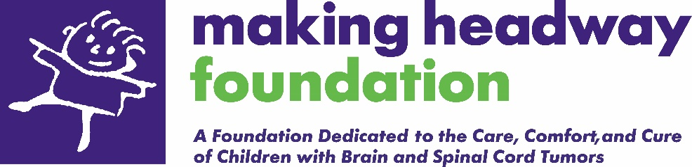

MAKING HEADWAY SOCIAL WORKER / FAMILY LIAISON

JOIN OUR TEAM

Come join the Making Headway Foundation Team as our Social Worker/Family Liaison. This position works directly with families that have had a child diagnosed with a brain and spinal cord tumor. By supporting our families, you would provide/coordinate care, offer emotional support, collaborate with local children’s hospitals, and lead our Ongoing Care Team of consultants. This is a unique opportunity to be part of a small, focused, passionate nonprofit that is fiercely dedicated to helping others.

ABOUT US

For the past 30 years, Making Headway Foundation has been providing a variety of services and support to families impacted by childhood brain or spinal cord tumors. Making Headway has a close working relationship with NYU Langone Hospital, as well as other Tri-State area hospitals. All applicants must be a licensed Social Worker (LMSW or LCSW) and have a caring and compassionate personality, the ability to work independently, and a proactive mindset to care for others.

The Making Headway office is located in Chappaqua, NY. The Social Worker/Family Liaison is a full-time, on-site position, with a starting salary of $80,000-$100,000 depending on qualifications and experience. Position includes medical and dental insurance plans as well are retirement contributions.

POSITION DESCRIPTION

Outreach and Follow-Up
Contact newly referred families within 36 hours to get to know them, assess their needs, and introduce Making Headway’s array of services. Collaborate with other service providers and hospitals to ensure families can get the services they need. Most contact will be over the phone, in texts, or via video calls; however, we encourage personal visits as often as possible (families are located throughout the tri-state area, with a majority living in NYC). This position will build long-term relationships and stay in contact with families throughout their journey, including regular follow-up calls.

Case Management
Provide information/resources/assistance as needed. These services may be very varied and include Making Headway programs, state-funded programs, hospital-based services, or programs offered by other non-profits. Areas of support may include mental health, housing, medical care, educational advocacy, financial support, and legal assistance. For example, Making Headway provides financial assistance in cases of extreme need for household and daily care such as rent, food, utilities, and other basic needs. In a new program, the Family Liaison will work with a contracted firm to provide legal assistance that would address immigration concerns, government benefits, housing issues, and insurance disputes. This Social Worker/Family Liaison will help determine which families need services and manage internal and external referrals. There are also opportunities to develop new programs to address any unmet needs.

Promote and connect families to other Making Headway opportunities, such as becoming a volunteer or advocate, participating in family photoshoots or custom events, applying for our college scholarships, fundraising, and sharing their story with others in our community.

Ongoing Care Team Coordination
Coordinate care by networking with hospital social workers and medical teams to understand what services and support are necessary. Based on the family’s needs, determine and coordinate referrals to psychiatrists, psychologists, and educational consultants on the Making Headway Ongoing Care Team. The current Ongoing Care Team consists of 20 outside consultants, to which you will make referrals based on each family’s specific needs.

Manage and Maintain Database
Social Worker/Family Liaison will be responsible for recording all their work/interactions in a custom database, including detailed family notes and tracking the services that were provided.

Building Partnerships
The Social Worker/Family Liaison will solidify and build partnerships with local nonprofits and hospitals. This includes working with other social workers to ensure that any family that has a child diagnosed with a brain tumor has the opportunity to be referred to Making Headway. We also expect approximately one day/week will be spent onsite at the NYU Hassenfeld Center (Manhattan), working in close partnership with their staff.

Other
- Meetings with hospital staff and medical teams to discuss the services Making Headway provides, as well as weekly, in-person meetings with new families at the hospital (NYU Hassenfeld Center).
- Outreach and connect with families who want to attend fun family events. This includes three large Making Headway events each year, as well as a number of smaller activities. For the large events, you are expected to help with outreach, preparation, and support during the event.
- Create/conduct needs assessment survey for families.
- Update and compile “Resources Package” for new families.
- Occasional availability on nights and weekends to respond to families with emergency needs.
- Other tasks as needed.

Requirements
- Expertise in a variety of social work fields, including psycho-social focus on children and families, trauma, medical, and/or mental health.
- LMSW or LCSW (NY State preferred)
- Experience in crisis situations.
- Computer skills: Microsoft Word, PowerPoint, and Excel
- Spanish speaking a plus

Limited Hybrid Options and Flexible Days
Remote days are possible after six months. Normal office hours are 9am-5pm, Monday-Friday.

How to apply: Send a detailed, human-written cover letter and resume to dan@makingheadway.org or mail to 115 King Street, Chappaqua, NY 10514. Indicate "FAMILY LIAISON - Your Name" in the subject line. For more information, visit us at: www.makingheadway.org.

